REPORT ON 2025 ANNUAL MANDATORY HEALTH SCREENING AND CERTIFICATION OF FOOD/DRINK VENDORS AND HANDLERS IN AWUTU SENYA EAST MUNICIPALITY
1.0. INTRODUCTION
Public Health Researchers have attributed the alarming rate at which food/drink borne infection cases are increasing partly due to the consumption of ready to eat food/drink from outside the home environment. Some Public Health Practitioners are of the view that the food/drink preparation and vending sites are two key areas that must be concentrated on during activities and programs of food safety, others are also of the view that the vendor’s health status must also be assessed since the health of the Handlers can also contribute to the wholesomeness of the food/drink.
Since Environmental Health Officers are mandated by the Local Governance Act 936 of 2016 which states any person who discharges the duties of a Medical Officer or Sanitary Inspector or the Environmental Health Officer under the Infectious Disease Ordinance (CAP78) for any area shall be an officer of the Assembly of the area for the purpose of giving effect to an enforcing bye-laws relating to public health made by the District Assembly, the Unit has undertaken the above captioned exercise and submit this report for further action.
2.0. TARGETED GROUPS
The unit targeted an estimated four thousand (4000) food /drink vendors and handlers across the Municipality
These were made up of
- Kitchen staff of institutions
- Public and private basic schools JHS, SHS and tertiary schools
- Hotels, guest house food drink vendors and handlers
- Eating and drinking bar food drink handlers
- Restaurant food/drink handlers
- General (street) food/drink vendors and handlers
- Caterers and staff of Ghana school feeding Programme
- Food and drink processing factory etc.
- Kitchen staff of institutions
- Public and private basic schools GHS SHS and tertiary schools
- Hotel guest house food drink vendors and handlers
- Eating and drinking bar food drink handlers
- General (street) food/drink vendors and handlers
- Caterers and staff of Ghana School Feeding Programmes
- Food and drink processing factories etc.

3.0. ORGANIZERS OF THE PROGRAMME
The program was jointly organized by the Environmental Health Unit of the Assembly in partnership with its accredited medical laboratory service provider.

4.0. APPROACH AND METHODOLOGY
- To make accessibility easy affordable and convenient 60 health screening and certification Centre were created across the municipality so that vendors would not spend too much time and money to access medical lab services into(tests)
- Prior to the exercise intensive public sensitizations were carried out during both day and night at least 3 days to the exercise at a particular health screening and certification Centre and during the exercise using a mobile Van mounted with a PA system to enable vendors to prepare adequately
- Vendors declared feet were issued with on the spot one-time health certificate ID card duly signed by the Municipal Coordinator Director and Municipal Environmental Health Officer to be worn conspicuously on their neck and displayed at where food are being processed to enable the consuming public to easily identify them as having been health screened and certified fit to prepare and sell food drink for public consumption
- . A Municipal Environmental Health inspection Team was constituted to go round monitor, educate and call to order vendors who either did not go through the exercise or operated with invalid health certs and sell in insanitary conditions.

5.0. OUTCOME OF THE EXERCISE
S/No | Name of zonal council | Number of vendors registered and health screened | Number of vendors declared fit and health certified | Number of vendors with typhoid fever (not fit) | % of vendors who are healthy carries of typhoid fever | % of vendors screened by Zonal Council | ℅ Declared fit and health certified
1 | IRON CITY | 445 | 445 | 0 | 0 | 14 | 100
2 | CP/WALANTU | 330 | 329 | 1 | 0.30 | 10 | 99.70
3 | OPEIKUMAH | 536 | 534 | 2 | 0.37 | 17 | 99.63
4 | AKWELEY/KAEMEBRE | 855 | 853 | 2 | 0.23 | 27 | 99.77
5 | OFAAKOR | 641 | 641 | 0 | 0 | 20 | 100
6 | ADAM NANA | 346 | 346 | 0 | 0 | 11 | 100
Total |  | 3153 | 3148 | 5 | 0.16 | 100 | 99.84

5.0. OUTCOME OF THE EXERCISE
S/No | Name of zonal council | Number of vendors registered and health screened | Number of vendors declared fit and health certified | Number of vendors with typhoid fever not fit | % of vendors who are healthy carries of typhoid fever | % of vendors screened by Zonal Council | ℅ Declared fit and health certified
1 | IRON CITY | 1507 | 1487 | 20 | 0 | 14 | 100
2 | CP/WALANTU | 1370 | 1278 | 98 | 0.30 | 10 | 99.70
3 | OPEIKUMAH | 1246 | 1160 | 210 | 0.37 | 17 | 99.63
4 | ADAM NANA | 1570 | 1523 | 47 | 0.23 | 27 | 99.77
5 | AKWELEY/KAEMEBRE | 1058 | 1011 | 47 | 0 | 20 | 100
6 | OFAAKOR | 1009 | 929 | 80 | 0 | 11 | 100
Total |  | 7,760 | 7,388 | 502 | 0.16 | 100 | 99.84

6.0. BRIEF ANALYSIS OF RESULTS
Out of the total number of 7,760 vendors registered and health screened during the period under review, 7,388 accounting for 99.84 % were found, declared and certified fit to prepare and serve food and drink to the public. This is because they were not found to be healthy carriers of typhoid fever (Reference 2025 Annual Report).
Out of the SIX (6) Zonal Councils within the Municipality, Adam Nana Zonal Council registered and presented the highest number of 1570 representing 27% of the total number of vendors presented for the exercise. A total number of 502 out of the 7,760 screened were found to be healthy carriers of Typhoid fever, a communicable disease transmissible via unhygienic preparation and sale of food/ drink.
Ofaakor Zonal Council registered and presented the lowest number of vendors (1009) accounting for 10% of the total number of vendors registered and health screened with 80 of the vendors being healthy carriers of Typhoid fever

6.0 FOOD/DRINK VENDING SITES INSPECTED

S/no. | Food/drink preparation and vending sites | No. targeted | No. Visited | % visited
1 | Public Basics Schools kitchens | 47 | 47 | 100%
2 | Private Basic School kitchens | 329 | 329 | 100%
3 | Restaurants | 181 | 181 | 100%
4 | Bakeries | 200 | 200 | 100 %
5 | Eating bars | 438 | 438 | 100%
6 | Drinking bars | 5701 | 5701 | 100%
7 | Water processing factory | 48 | 48 | 100 %
8 | Other institutional centers | 28 | 28 | 100%


Picture showing Environmental Health Staff, Medical Lab Staff and food vendors at Iron City Zonal Council screening Centre on 9th August, 2025.
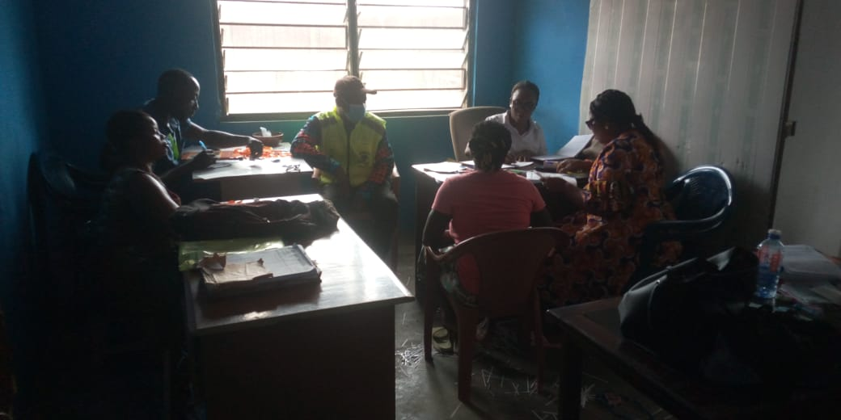
A Photograph Showing the MEHO Supervising Health Screening and Certification of Food and Drink Vendors at Iron City Zonal Council Office on 10th August, 2025

